**1. Setup Environment:**

A. the libs should be imported by pyCharm:

If there is any warning prompted that they could not be found in IDE, please download them by website and import.

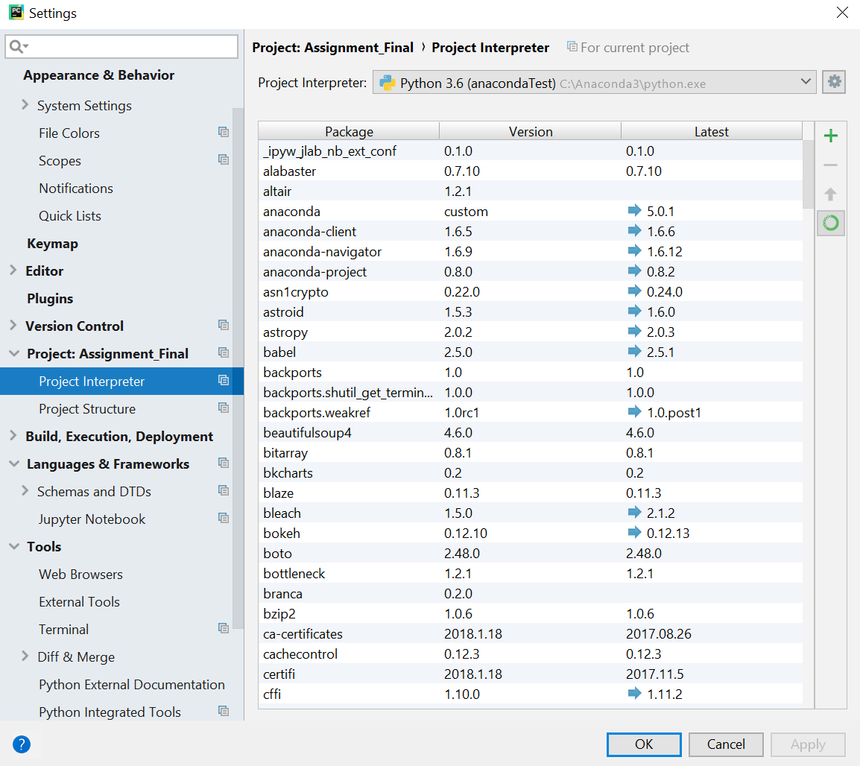

import xgboost as xgb

import seaborn as sns

from haversine import haversine

import datetime as dt

from sklearn.decomposition import PCA

from sklearn.cluster import MiniBatchKMeans

from tpot import TPOTRegressor

from sklearn.model_selection import train_test_split

from sklearn.model_selection import KFold

import urllib #for url stuff

#import gmaps #for using google maps to visulalize places on maps

import re #for processing regular expressions

import datetime #for datetime operations

import calendar #for calendar for datetime operations

import time #to get the system time

import scipy #for other dependancies

from sklearn.cluster import KMeans

from haversine import haversine # for calculating haversine distance

import math #for basic maths operations

import seaborn as sns #for making plots

import matplotlib.pyplot as plt # for plotting

import os # for os commands

# from scipy.misc import imread, imresize, imsave # for plots

import plotly.plotly as py

import plotly.graph_objs as go

import plotly

from bokeh.palettes import Spectral4

from bokeh.plotting import figure, output_notebook, show

from IPython.display import HTML

from matplotlib.pyplot import *

from matplotlib import cm

from matplotlib import animation

import io

import base64

import math

import folium

import xgboost as xgb

from sklearn.decomposition import PCA

from sklearn.cluster import MiniBatchKMeans

import warnings

from ggplot import *

import tweepy

from tweepy import Stream

from tweepy import OAuthHandler

from tweepy.streaming import StreamListener

import time

from snownlp import SnowNLP

import tweepy # To consume Twitter's API

# For plotting and visualization:

from IPython.display import display

import matplotlib.pyplot as plt

import seaborn as sns

from textblob import TextBlob

import re

from credentials import *

**B. Install ImageMagick-7.0.7-Q16 for generating animation.gif:**

Step1: download: https://www.imagemagick.org/script/download.php

Step2: Install it according to relative path.

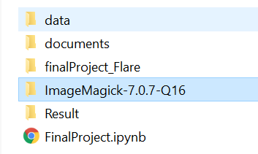

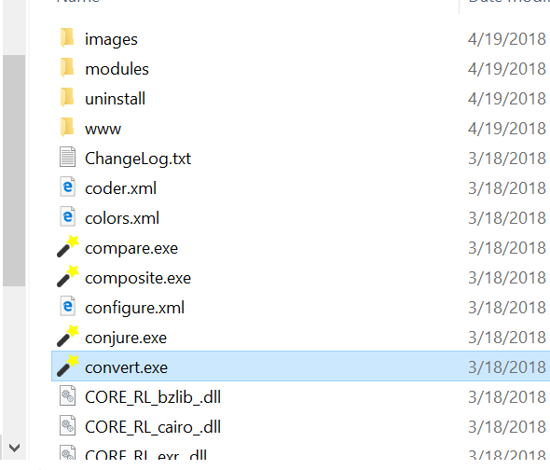

**C. Install pyCharm & Jupyter on local.**

**2. Run the codes:**

For python:

Step1: Start the project on Pycharm by .ipynb

Step2: Start the server and connected to notebook.

**Appendix. All the results generates**

